Act Report

Author: Otto Roberson

Introduction
This brief analysis covers tweets from the WeRateDogs twitter account, @dog_rates. My analysis looks at the trend in favorites and retweets over time, favorite dog stage, top-10 dog names, and common words in the text field.
Analysis
Retweets and Favorites for WeRateDogs over time:
In analyzing the dataset, I recognized an increasing trend in the favorites and retweets over the time frame studied. Both of the retweets and favorites variables have a steady upward trend as observed in the chart below.
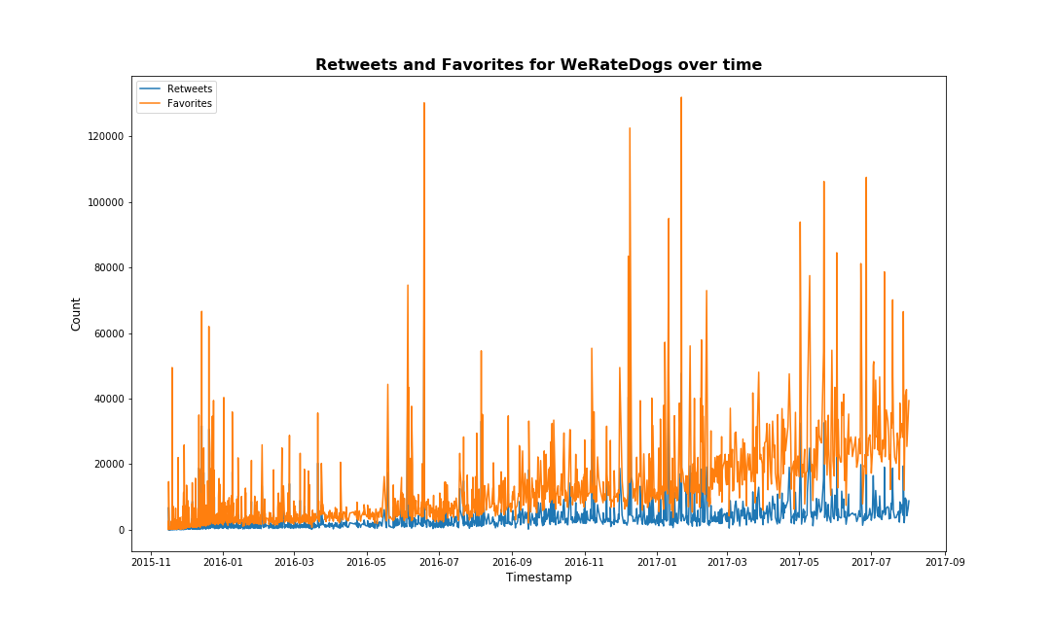
The increase in favorites is more noticeable when compared to retweets. There are also several large-value outliers in favorites representing very popular tweets. One caveat is that I didn’t extrapolate the dataset to understand popularity or post volume for this particular account, so there might be a higher number of posts early on. Although this doesn’t affect directly our graph it might assist in capturing and understanding the big picture for this particular trend.

Favorite Dog Stage:
I also looked at the dog stages values in this dataset, and was able to perform some aggregation to extract information to visualize the number of values for each dog stage, and in the figure below it’s evident that the pupper stage is the most frequent.
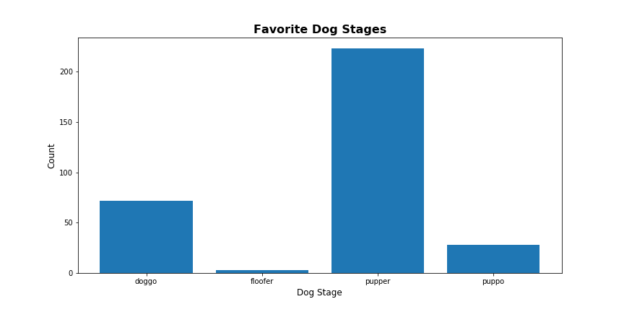
From this we can formulate an opinion that puppers have a tendency to attract more interest. Although I didn’t investigate the possible reasons for this, perhaps it’s because in the images used they are doing something silly or funny.
Top 10 dog names:
There are many values missing in the name field, and also many lower-case words such as ‘aa’ which wouldn’t be useful to include. For this dataset, I can deduct that Charlie is the most common name listed, with Lucy, Cooper, and Oliver close behind. However I would hesitate to fully trust the results, given the large number of erroneous values – it might be possible even that the Twitter account owner added whatever name he wanted to on the spur of the moment. In the figure below I’ve plotted the most common dog names, found by filtering the name field.
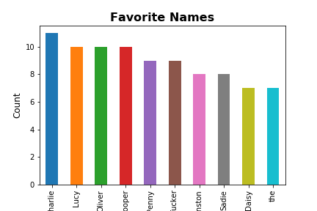

Common words in the text field:
I initially thought about filtering the text field to find additional information, however I think that the data is fairly interesting as is. By creating a word cloud I was able to quickly visualize words that frequently appear, below.
